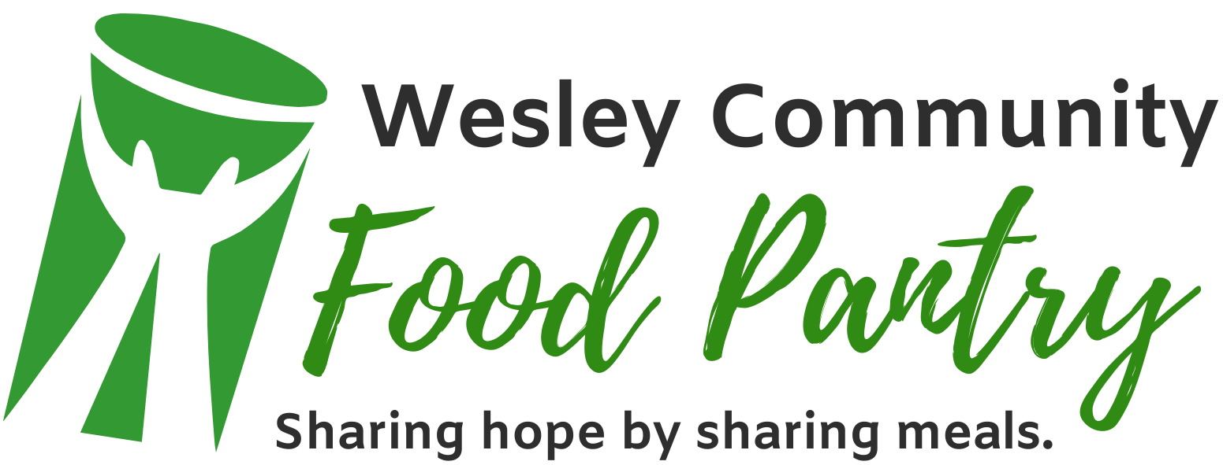

**Food Pantry distribution dates are the 1st and 3rd Fridays of every month from 10am – Noon.**

We thank and appreciate our partners:

Harry Chapin Food Bank

Midwest Food Bank

Publix

And our many volunteers who make the food pantry possible.

*Then Jesus declared, “I am the bread of life. He who comes to me will never go hungry, and he who believes in me will never be thirsty.”*

*John 6:35*



